Gaman

Cisco Finesse Transfer Gadget for Finesse 12.X

##### Document history

|  |  |  |  |
| --- | --- | --- | --- |
| Date | Person | Version no. | Description |
| 2020-02-19 | Marek Słomiński | 1.0 | First version of the document |
| 2022-08-29 | Marek Słomiński | 1.1 | Add Make Call Button Type |
| 2022-09-13 | Marek Słomiński | 1.2 | Make Call DTMF functionality |
| 2023-05-10 | Marek Słomiński | 1.3 | Conference functionality, Icon display mode |
|  |  |  |  |

# Table of Contents

Table of Contents 1

Introduction 3

Gadget package 3

Package contents 3

Requirements 3

Gadget Configuration 5

Gadget Features 9

Icon View 9

Transfer Buttons 10

Make Call Buttons 10

Make Call Input Field 10

Conference buttons 11

Button options 11

Deployment 12

Finesse Server deployment (via sFTP) 12

Buttons mode displayed on menu 13

Gadget Troubleshooting using browser console 15

Contact information 16

# Introduction

Cisco Finesse Transfer Gadget has been designed to become an integral part of Cisco Finesse UI. It extends Cisco Finesse functionality by predefined transfer buttons. The following button types are available:

* Direct Transfer Button
* Conference
* Consult Call Button
* Make Call Button

Agent may click on one of them quickly during the call and transfer active call to the predefined phone number. Gadget is highly configurable. The following settings can be modified by System Administrator: Place where the gadget will be rendered, Type of buttons, Number of buttons, Color (green, red, blue, orange, grey, white), Label and Phone number defined for each button separately.

Below screen shows the gadget in “button” mode displayed in the “panel”.

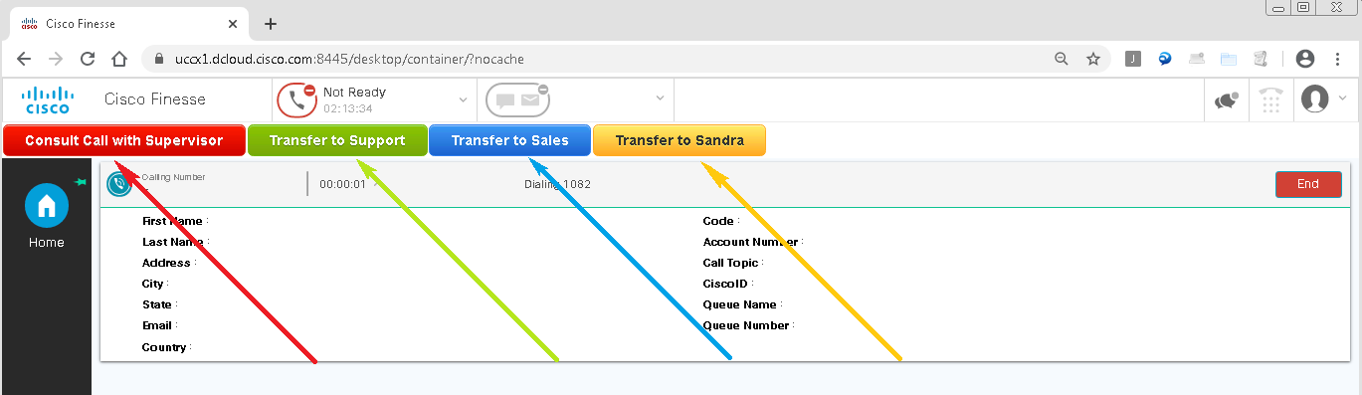

Below screen shows the gadget in “icon” mode displayed in the “menu”.

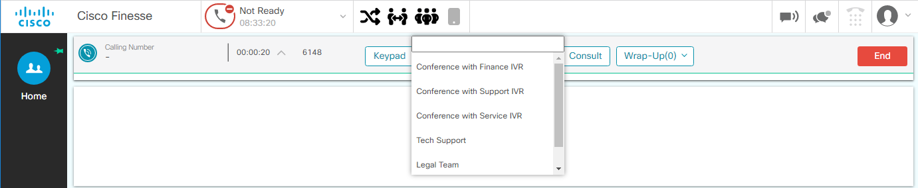

# Gadget package

All files needed for installation are available in the **TrasferGadget** directory.

## Package contents

* **TransferGadget.xml** – Main gadget file. Contains basic gadget configuration, gadget layout and binds JavaScript files into one working package.
* **TransferGadget.min.js** – File containing logic for gadget to work. Contains minified JavaScript code.
* **TransferGadget.css** – File describing style of gadget in CSS.
* **Config.js** – File containing configuration of the gadget.
* **img** – Folder used to store all static images displayed on the gadget UI.

## Requirements

The transfer gadget requires Cisco Finesse 12.X including UCCE, PCCE and UCCX.

# Gadget Configuration

To put some flexibility into the gadget, we have prepared a special configuration file that allows to change some settings. Entire configuration is stored in one file. Below is the example of **Config.js** file:

/**

 *  If hideInactiveButtons flag is set to true (hideInactiveButtons = true) then all buttons will be hidden if they are inactive (e.g., there is no active call).

 *  Otherwise (hideInactiveButtons = false) all buttons will be visible all the time. They will be just disabled if transfer is not available.

 *  NOTE!

 *  Feature doesn't work if make call buttons are defined

 */

var hideInactiveButtons = false;

/**

 * displayButtonsOn is used to indicate a place where to render the gadget buttons on the Finesse UI

 * Valid values are:

 *   - panel - (default) buttons will be displayed in a panel that will be presented underneath the agent state functionality

 *   - menu - buttons will be displayed in the Finesse upper menu

 *            (NOTE! - the space in menus limited and you can set only few buttons in this mode)

 */

var displayButtonsOn = 'menu';

/**

 * displayButtonMode is used to determinate how the gadget will render the buttons on the Finesse UI

 * Valid values are:

 *   - buttons - (default) buttons will be displayed as UI regular buttons

 *   - icons - buttons will be presented as list items displayed on the popup once the user clicks the button icon

 *             (NOTE!) - this mode can only be set if the displayButtonsOn is set to menu

 */

var displayButtonMode = 'icons';

/*

 * Delay in ms that will be used to send DTMF's to call when the call is initiated by make call functionality. Default 5000 ms.

 */

var makeCallDTMFDelay = 5000;

/*

 * Declaration of transfer buttons array. Shouldn't be modified.

 */

var Buttons = new Array();

/**

 *  Each block of 'Buttons.push' defines one button:

 *      - name : Button label visible on Cisco Finesse UI

 *      - id : Button id not visible for Agent

 *      - number : Transfer destination phone number

 *      - type : Button type. Currently, the following buttons are supported:

 *          * conference

 *          * consultCall

 *          * directTransfer

 *          * makeCall

 *      - color : Button color (red, green, blue). Leave this field empty for grey.

 *      - size : Button size (small, large). Leave this field empty for medium size.

 *      - enableInput : feature used only for "makeCall" buttons, enables additional field that is used to enter DTMF's that will be sent when the call is established.

 */

Buttons.push({

    name : 'Consult Call with Supervisor',

    id : 'supervisor',

    number : '1080',

    type : 'consultCall',

    color : 'red',

    size : 'small'

});

Buttons.push({

    name : 'Transfer to Support',

    id : 'support',

    number : '1080',

    type : 'directTransfer',

    color : 'green',

    size : 'small'

});

Buttons.push({

    name : 'Make Call to 1080',

    id : '1080',

    number : '1080',

    type : 'makeCall',

    color : 'blue',

    size : 'small',

    enableInput : true

});

Buttons.push({

    name: 'Conference with IVR',

    id: 'conf_3015',

    number: '3015',

    type: 'conference',

    color: 'red',

    size: 'small'

});

Description of all configurable parameters:

* **Hide inactive buttons**

If *hideInactiveButtons* flag is set to true (*hideInactiveButtons* = true) then all buttons will be hidden if they are inactive (e.g., there is no active call). Otherwise (*hideInactiveButtons* = false) all buttons will be visible all the time. They will be just disabled if transfer is not available.

|  |  |
| --- | --- |
| Note | If you make call buttons in a configuration, the hide inactive buttons feature will not be available.  Gadget will always display buttons as display is evaluated based on agent state:   * make call button works only if agent doesn’t have an active call. * transfer/consult buttons need active call on agent side |

* **Display Buttons On**displayButtonsOn parameter defines the place where the gadget will generate the buttons. The parameter can take on of the following values:
  + panel – buttons will be generated at a dedicated panel that will be displayed underneath the agent’s state control widget.
  + menu – buttons will be generated on the Finesse upper menu (next to agent state control widget).
* **Display Buttons Mode**displayButtonMode parameter defines the way how gadget will generate buttons on gadget. The parameter can take on of the following values:
  + buttons – gadget buttons are rendered in traditional way (as buttons)
  + icons – gadget renders icons that bind buttons by type. When the user clicks on the button a popup is displayed and the buttons are displayed as list items.

|  |  |
| --- | --- |
| Note | If the combination of the parameters is set as:   * displayButtonsOn = ‘menu’ * displayButtonMode = ‘buttons’   You may experience a lack of space available on the upper menu. In this case it is recommended to:   * use only few buttons with short labels displayed on UI. * remove all the unused gadgets from the <header> tag in Finesse desktop configuration. |

* **Make Call DTMF Delay**

makeCallDTMFDelay parameter defines the timeout/delay in milliseconds that will be used by gadget to start sending DTMF’s provided in make call input field. Default delay is 5000ms. The parameter can be used if the call is transferred to IVR that has prompts that cannot be barged in. The delay is calculated from the point when the call becomes active.

* **Buttons configuration**

Each block of 'Buttons.push' defines one button:

* name: Button label visible on Cisco Finesse UI
* id: Button id not visible for Agent
* number: Transfer destination phone number
* type: Button type. Currently the following types of buttons are supported: **conference**, **consultCall, directTransfer** or **makeCall**.
* color: Button color (red, green, blue, orange, grey, white). Leave this field empty for white.
* size: Button size (small, medium, large). Leave this field empty for medium size.
* enableInput: applicable only for the make a call buttons, Boolean value that enables/disables additional input field for passing DTMF’s that need to be sent to IVR.

|  |  |
| --- | --- |
| Note | All buttons defined in the configuration need to have all defined above parameters. Please use the following code as a template (fill it with the needed data) and paste at the end of the configuration file. The template represents a single button:  Buttons.push({      name : 'Consult Call with Supervisor',      id : 'supervisor',      number : '1082',      type : 'consultCall',      color : 'red',      size : 'small'  }); |

**Deprecated parameters**

Below is the list of the configuration parameters that are not in use anymore and can be removed from the config file:

|  |  |
| --- | --- |
| **Parameter name** | **Description** |
| **gadgetHeight** | Removed in version 12.X.  The gadget hight is now controlled directly by the size of the buttons.  **Previously**:  gadgetHeight specifies height of the gadget. Gadget height should be adjusted to buttons size. 29px fits perfectly for small buttons. Set 51px for large buttons or 39px for regular buttons. |

# Gadget Features

## Icon View

One of the main problems with initial version of the gadget was a requirement of additional space needed to render the buttons on Finesse UI – it consumed space for gadgets that were used by agent to provide service to customers.

To resolve the problem, new type of gadget view was created – Icon View presented on the below screen.

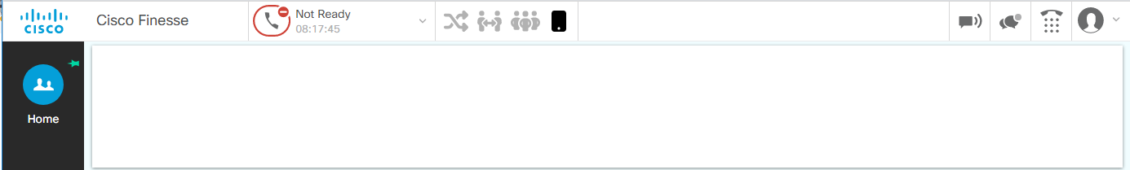

In this view buttons are grouped by 4 icons:

*  - icon binds all direct transfer buttons
*  - icon binds all consult call buttons
* 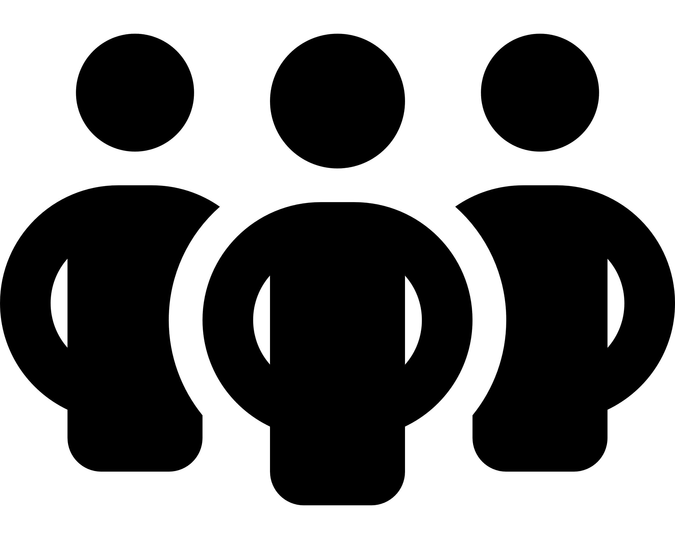 - icon binds all conference buttons
*  - icon binds all make call buttons

|  |  |
| --- | --- |
| Note | If the number of buttons of a specific type is 0, icon for this type will not be presented on the UI (to reduce the space needed by gadget on the Finesse UI) |

Once user clicks on the button a popup will be displayed. Buttons are displayed as list items that can be clicked as buttons to initiate the functionality. Below is the screenshot that shows the example button list for conference:

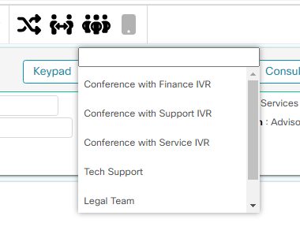

As presented on screen the list contains items that can be selected and an input field that allows to filter/search options that are needed for agent.

|  |  |
| --- | --- |
| Note | The search/filter input field will be only presented when the number of items on the list is higher than 5. |

## Transfer Buttons

Transfer gadget supplements Cisco Finesse agent desktop and allows to configure a predefined list of transfer buttons. Each of them can be set separately and transfer an active call to the different phone number. Each transfer can be set as: direct transfer or consult transfer. Here is a view that shows the button layout under Finesse UI:

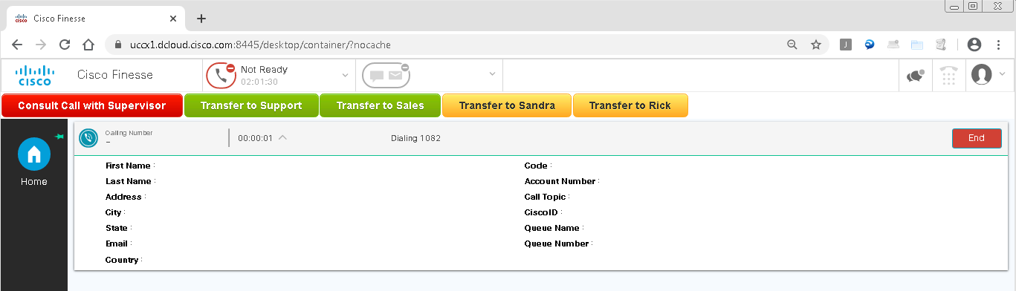

## Make Call Buttons

Make Call buttons were designed to help agents quickly initiate calls to known numbers. They are available only when the agent doesn’t have an active call (is in ready or not ready state). When the agent clicks on the button, Finesse initiates a new call to the number assigned to button.

## Make Call Input Field

Sometimes when the call is initiated there is a need to pass the DTMF’s to the called IVR. When those DTMF’s are known the Make Call Input Field can help to automate the process in entering digits to IVR.

The scenario for usage looks like this:

1. Agent enters the needed DTMF’s in the input field.
2. Agent presses Make Call button.
3. When the call is established, gadget waits for configured period and then sends DTMF’s to IVR.

Here is a screenshot that shows this functionality:



|  |  |
| --- | --- |
| Note | Input field has a built-in filter that only allows user to enter the numbers. If the user pastes the string with letters, the string will be trimmed to only numbers. |

## Conference buttons

Conference buttons were designed to help users to initiate the conference to known number. This type of buttons performs the following action:

1. When the user clicks the button, gadget initiates a consult call with the number configured on button.
2. Gadget awaits until the consult call is answered and is active (was answered by second side)
3. Gadget tries to merge 3 calls (customer, agent and consult call) into a single 3-poit conference.

Using this button should reduce the number of clicks and time needed to establish conference.

## Button options

Buttons can operate in two different modes:

* disabled - buttons are enabled only during the active agent’s call. If transfer is not available, then all transfer buttons are disabled. Below screenshot shows the inactive buttons (all buttons disabled and displayed in the same color).

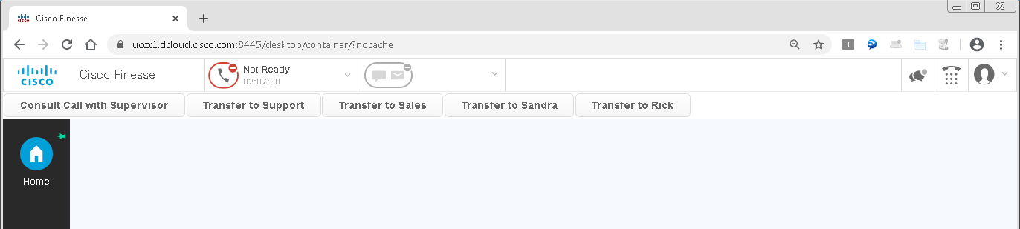

* hidden - buttons are only visible on UI when the call is active (feature available if *hideInactiveButtons* flag is set to true).

If transfer fails for any reason (e.g., transfer number is not reachable) then call won’t be transferred, and buttons became active again. In such case error message will be logged in browser console.

Administrators can set different sizes and colors of the button. Here is a screenshot that shows buttons in all sizes and colors under Finesse UI.

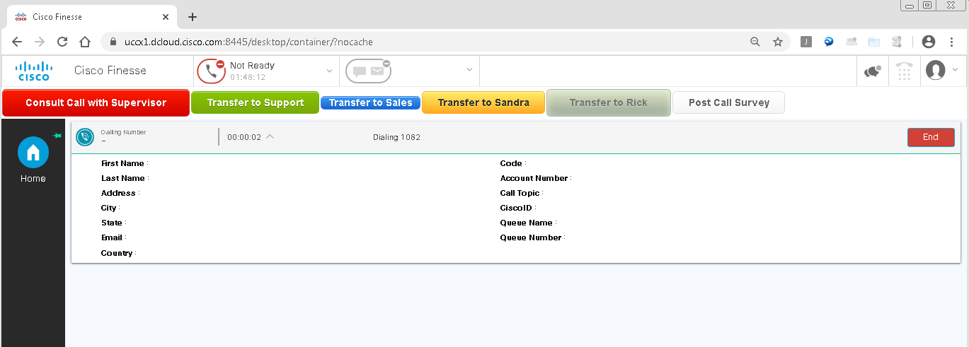

# Deployment

## Finesse Server deployment (via sFTP)

To deploy gadget using Finesse as a Web Server please use default procedure described in this documentation (documentation for version 10.X but can be used to higher releases):

<https://www.cisco.com/c/en/us/td/docs/voice_ip_comm/cust_contact/contact_center/finesse/finesse_1001/user/guide/CFIN_BK_CF7BB5C7_00_cisco-finesse-administration-1001/CFIN_BK_CF7BB5C7_00_cisco-finesse-administration-1001_chapter_01110.html>

1. Connect to Cisco Finesse sFTP service using 3rdpartygadget account and create **TransferGadget** folder so the final path should look like this:
   1. //files/**TransferGadget**/
2. Upload all Gadget files to //files/**TransferGadget**/ directory keeping the following structure of the files:

**TransferGadget**

**├ img**

| **├** **conference.svg**

| **├** **consultCall.svg**

| ├ **directTransfer.svg**

| **└** **makeCall.svg**

**├ TransferGadget.xml**

**├ TransferGadget.min.js**

**├ TransferGadget.css**

**└ Config.js**

1. Log in to the **Cisco Finesse Administration Portal (cfadmin)**.

https://<finesse_publisher_node>:<port>/cfadmin

where:

**finesse_publisher_node -** is the hostname or IP address of the Finesse publisher node.

**port -** is the port number on which the Finesse Admin portal is hosted (for UCCE/PCCE do not enter the port number, for UCCX enter 8445)

If the gadget is a global one, go to **Desktop Layout** tab. If the gadget needs to be only available for specific team, navigate to **Team Resources**, select team name from the list and then click on the **Desktop Layout** tab (at the lower part of the screen). Don’t forget to check “**Override System Default**” checkbox.

1. Add the following line to enable gadget:

***<gadget hidden="true">***

***/3rdpartygadget/files/TransferGadget/TransferGadget.xml***

***</gadget>***

Cisco Finesse gadgets usually are added as a separate tab in Cisco Finesse Agent desktop. In this case it is highly recommended to configure it directly in page xml tags. Such configuration will place transfer buttons on top of the page independently. They will be always visible no matter what tab is currently opened.

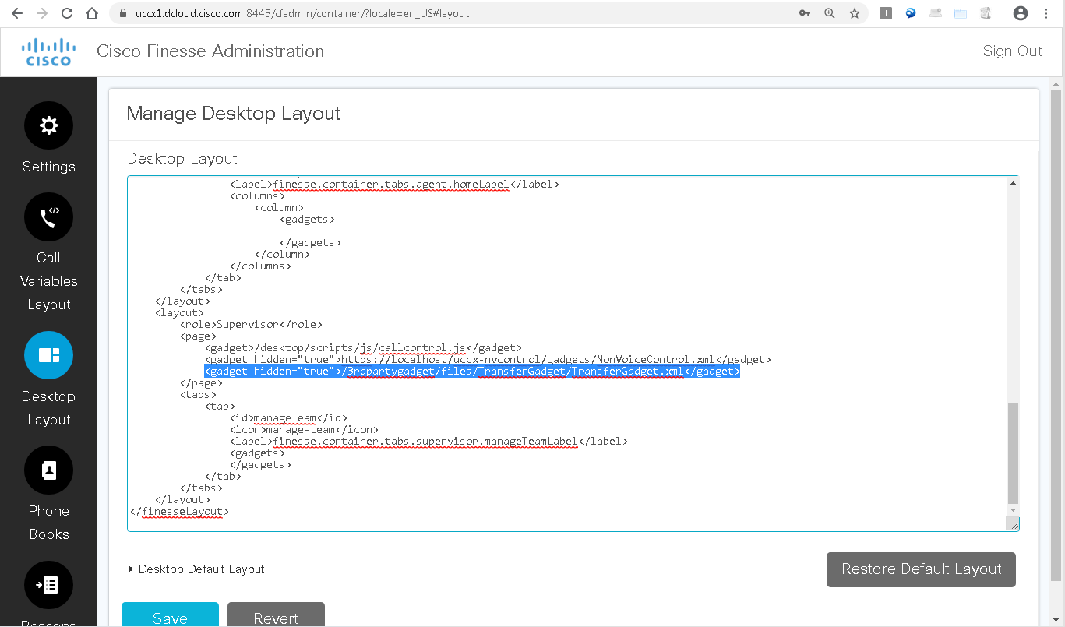

## Buttons mode displayed on menu.

If you are deploying the gadget in the “buttons” mode presented on menu you may encounter the problem of missing menu UI items – like keyboard used to initiate the new call. Below screen shows this situation:

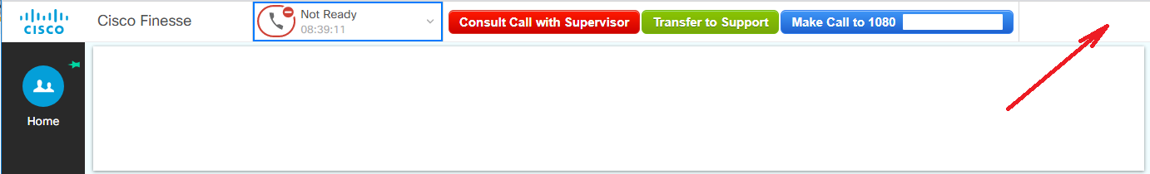

There is no general way to avoid this problem, but the administrator can:

1. Shorten the names of the button – ex. “Consult Call with Supervisor” may shorten to “SV”.
2. Remove all unused gadgets in the <header> section of the UI – this solution can be used when the agent is working on “voice” teams and doesn’t need gadgets dedicated for chat/email treatment.

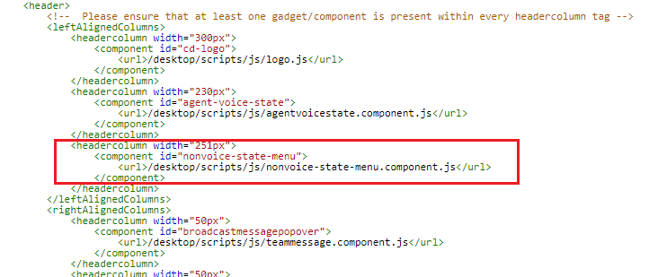

Although the nonvoice-state-menu gadget doesn’t show any items it still reserves space on the finesse UI (251px are consumed). If the agents don’t use this feature – it can be removed or commented out form UI layout.

After deployment of the described changes the UI changed, and the right-hand side buttons returned to their original position.

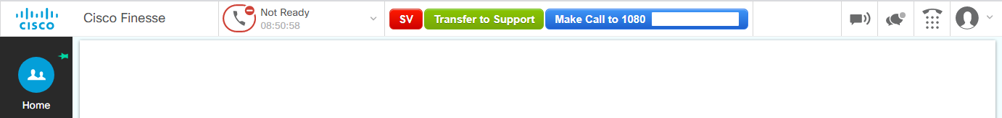

|  |  |
| --- | --- |
| Note | If optimizations don’t bring required results, then it indicates that the buttons display mode needs to be changed to “icons” mode. |

# Gadget Troubleshooting using browser console.

One of the approaches to troubleshoot the gadget, is to use the console which is building in every browser. To enable the console hit F12 button when the Finesse desktop is in focus.

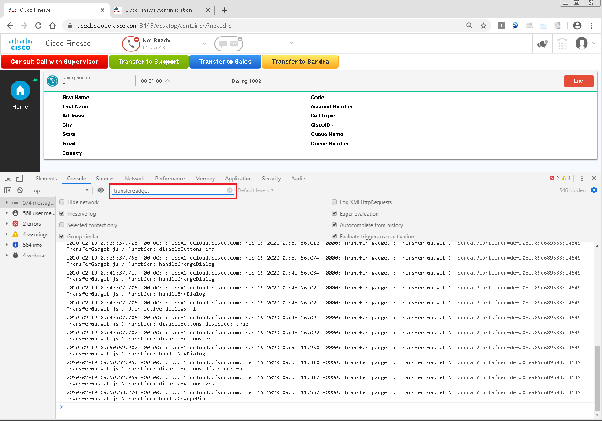

Troubleshooting procedure:

1. Enable browser console.
2. Clear the console from entries (trash can icon)
3. Perform the task where the issue is visible.
4. Download the entire console log.
5. Filter the log content using “TransferGadget” as a filter.
6. Analise the filtered log lines to see what is happening

# Contact information

If you enjoyed the content and you:

* Have an idea how it could be extended to improve the feature set of the gadget.
* Found an error in the gadget code that requires a fix.
* Found a bug/gap in the documentation.
* Have a project where you stuck and need an assistance.

Feel free to contact us. We will do our best to resolve any issues, add features to published solution.

Below the list of emails and places where you can find us.

**Email addresses**

General, Sales mailbox: **(**[**info@gaman-gt.com**](mailto:info@gaman-gt.com)**)**

Support mailbox: ([**support@gaman-gt.com**](mailto:support@gaman-gt.com)**)**

To find out more about Gaman Team and our project please visit our **Website:**

[**https://gaman-gt.com**](https://gaman-gt.com)

Find us in social networks:

|  |  |  |
| --- | --- | --- |
|  |  |  |
| **Linked In** | **Twitter** | **Upwork** |